COM Express® 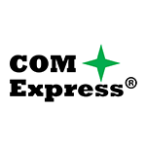

COM Express® is a PICMG® standard that defines a Computer-On-Module in a family of Small Form Factors (SFF). It is single board computers appropriate for a wide range of commercial and mil/aero applications. COM Express is used in Military/Aerospace, Transportation, Industrial, Medical and General Computing embedded applications. The COM modules plug into a baseboard that is typically customized to the application.
COM Express® including PCI Express Gen 3, 10GbE, SATA, USB 3.0, and high resolution video interfaces.

On request, we develop application-specific carrier boards and complete systems together with our customers.

